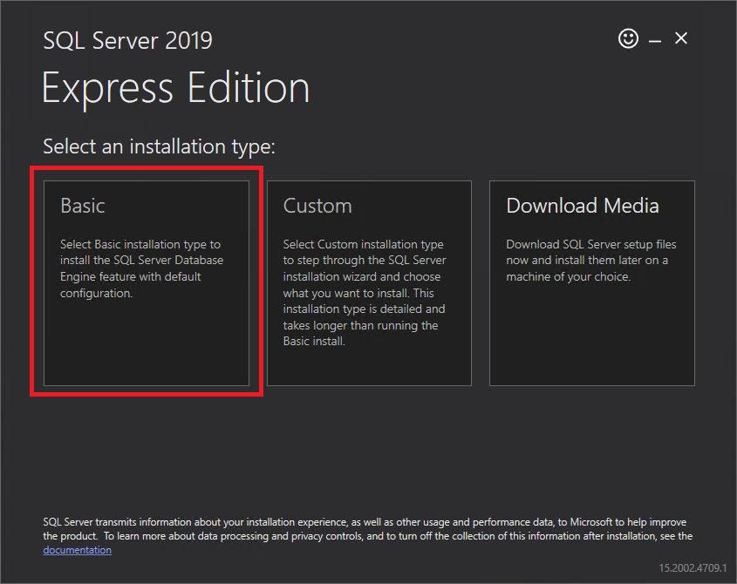

Before installing SQL Server 2019 Express, please export all Forecast 5 forecasts you wish to keep to an address on your local drive (or in the Cloud, as you may require)

You can download SQL Server 2019 Express, with the following download link:
https://go.microsoft.com/fwlink/?linkid=866658

Once this has downloaded, you can run this file to start the SQL Server installation. You will be presented with the following menu >>>
Select “Basic”. You will then be presented the license agreement: you can click “Accept”.

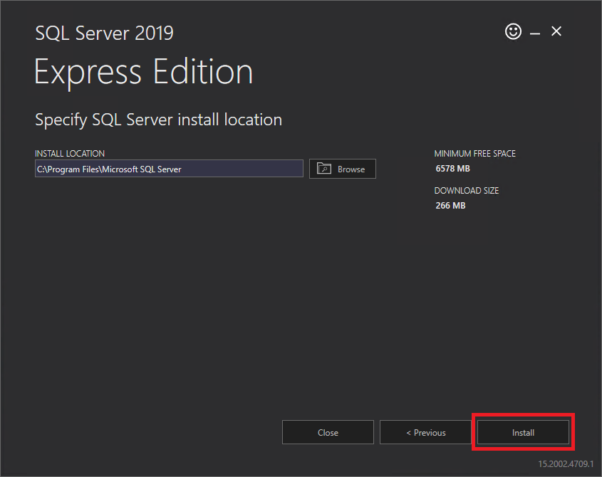
Next, you will be asked where to install SQL, leave this as it is and click “Install”.

This will begin the download of the installation files and begin the installation.
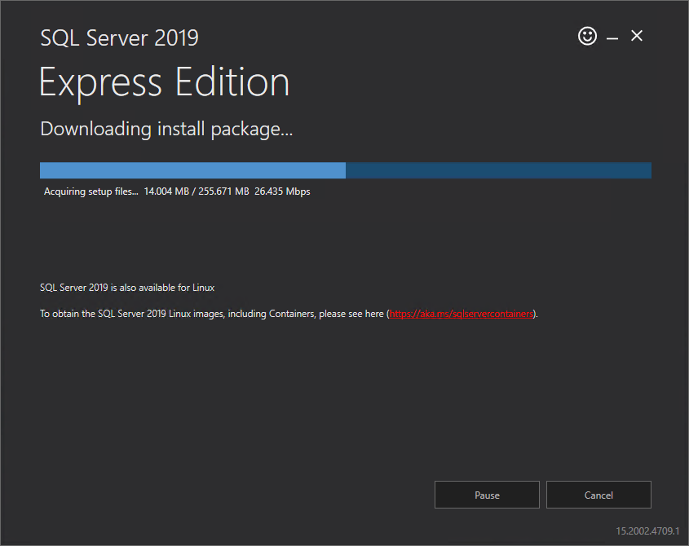

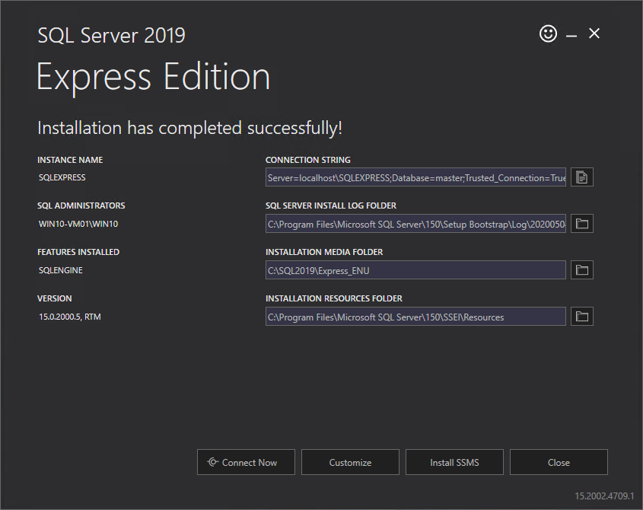

After a while, you will be presented with the complete screen, as seen here:

The installation of SQL Server 2019 Express has now been completed.

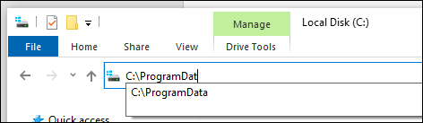
In order to now get Forecast 5 to use the newly installed server, you will need to edit the configuration file, located: C:\ProgramData\Forecast 5 Ltd\
This is a hidden folder for all Windows computers. To gain access to it, in the address bar, manually type the following: “C:\ProgramData” (As seen here >>)

This will take you to the root of the “ProgramData” folder, in which, the folder “Forecast 5 Ltd” resides. Go into this folder and you will now see the “Forecast5Config.xml” file. Right click on this file, select “Open with” and then select “Notepad”

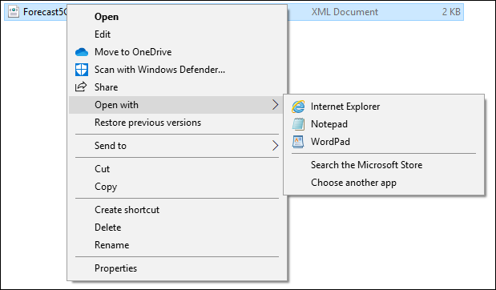

Please copy and overwrite, everything within, with the following:

<?xml version="1.0" standalone="yes"?>
<NewDataSet>
<xs:schema id="NewDataSet" xmlns="" xmlns:xs="http://www.w3.org/2001/XMLSchema" xmlns:msdata="urn:schemas-microsoft-com:xml-msdata">
<xs:element name="NewDataSet" msdata:IsDataSet="true" msdata:MainDataTable="Forecast5Config" msdata:UseCurrentLocale="true">
<xs:complexType>
<xs:choice minOccurs="0" maxOccurs="unbounded">
<xs:element name="Forecast5Config">
<xs:complexType>
<xs:sequence>
<xs:element name="ConnectionString" type="xs:string" minOccurs="0" />
<xs:element name="ValidCS" type="xs:boolean" minOccurs="0" />
<xs:element name="CallUpgrade" type="xs:boolean" minOccurs="0" />
<xs:element name="NextAutoUpdate" type="xs:long" minOccurs="0" />
</xs:sequence>
</xs:complexType>
</xs:element>
</xs:choice>
</xs:complexType>
</xs:element>
</xs:schema>
<Forecast5Config>
<ConnectionString>Data Source=localhost\SQLEXPRESS;Initial Catalog=Forecast5V3_2020;Persist Security Info=True;Integrated Security=SSPI;</ConnectionString>
<ValidCS>true</ValidCS>
<CallUpgrade>false</CallUpgrade>
<NextAutoUpdate>0</NextAutoUpdate>
</Forecast5Config>
</NewDataSet>

You may now save the changes by clicking “File” then selecting “Save”

Once this has been done, all you need to do is just reboot your computer and open Forecast 5 and re-import your forecasts.

