Forecast 5
Daily Cashflow

What Is Daily Cashflow?

The daily cashflow (DCF) is a rolling 90 day by day bank position projection based on your budget.

The DCF worksheet is first calculated by Forecast 5 using the data entered on the records in the budget and then the DCF worksheet can be amended for what you think will happen. Each change will update the projected daily closing bank position. Values can be moved from day to day or even removed allowing you to manage the actuals and expected bank position.

The worksheet does not update the records or change any monthly budget or cashflow figures and is reset to the original values when any record value in the budget is changed and the system records recalculation is run (eg by going to reports)

With this DCF projection you will be well placed to understand the company’s needs and daily financial position.

Note:
This Guide should be read in conjunction with Daily Cashflow as it appears in Forecast 5 on your computer screen in front of you.
If you don’t have a copy of Forecast 5, please download a free trial, here.

Set up of DCF

Weekend Payment day
The first parameter is to set the handling of payments scheduled to happen on Saturday and Sunday . These can be moved back to Friday or forward to Monday.
This setting is found under Settings > Preferences > Weekend Payment Day.

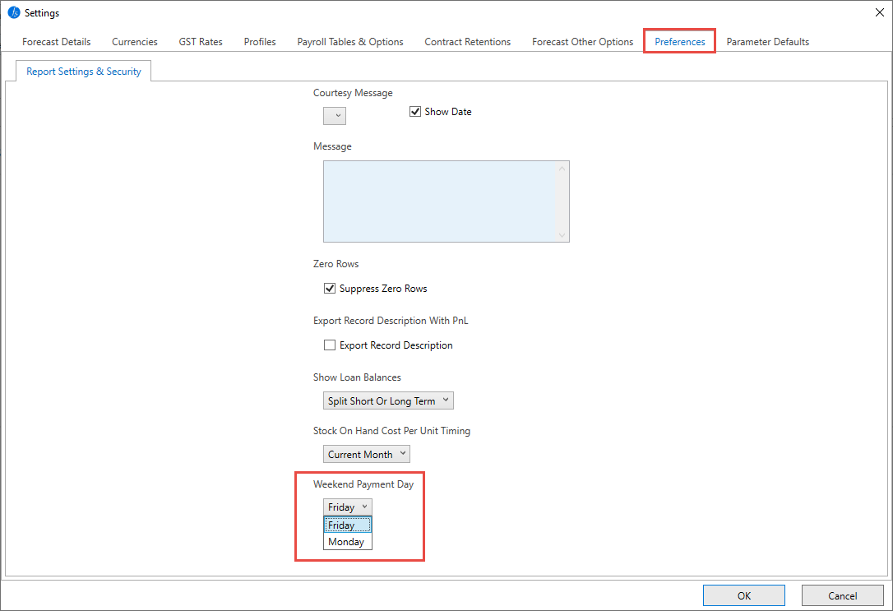

Frequency and Days Index
On all records in the budget (Sales, Costs, Bank, Assets, Loans, Capital Records, Forecast records, etc.), there is a frequency and Days Index option.

Frequency - The frequency determines if you are paying this amount Weekly, Fortnightly, Bi-monthly, or monthly.

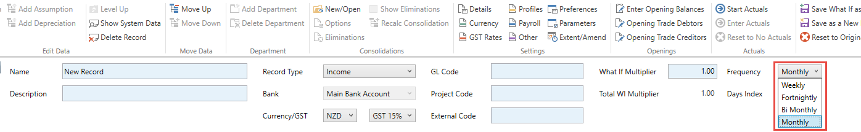

Day Index - The Day Index determines the day of the week that the payment/receipt will fall on, e.g. Day 1 to 7 for weekly. This day starts from the start date of the forecast.
For example, if your forecast start date is January, then selecting frequency = weekly and Day Index = 1 will make 5 weekly payments. Jan 1st, 8th, 15th, 22nd, and 29th.
Or Frequency = Weekly and Day Index = 4 will be Jan 4th, 11th, 18th, 25th four payments in January.

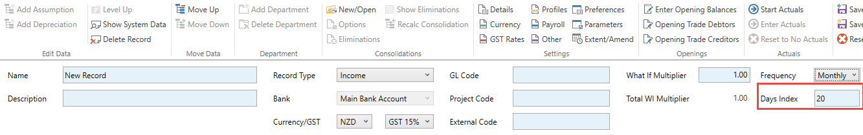

The calculation takes the monthly cash receipt or payment from the record and updates the DCF values, which will divide the cash value by the number of payments for the month and make the appropriate entry in the Daily Payments or Receipts field (viewable by “Show System data”).

Update all budget records to record expected DCF timings.

Create a Daily Cashflow Worksheet
The daily cashflow feature that is located on the Forecast 5 ribbon.
Selecting this tab (1) will open the DCF worksheet.
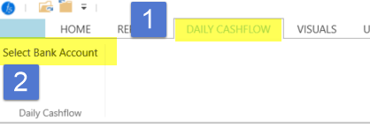

Select (2) “Select bank account”.
This will display the option to select a specified bank account or all bank accounts for which you want to show DCF.

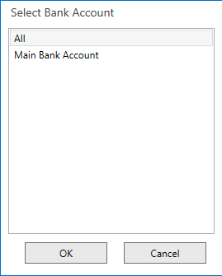

Once the calculation is complete, the worksheet layout will display as per below:

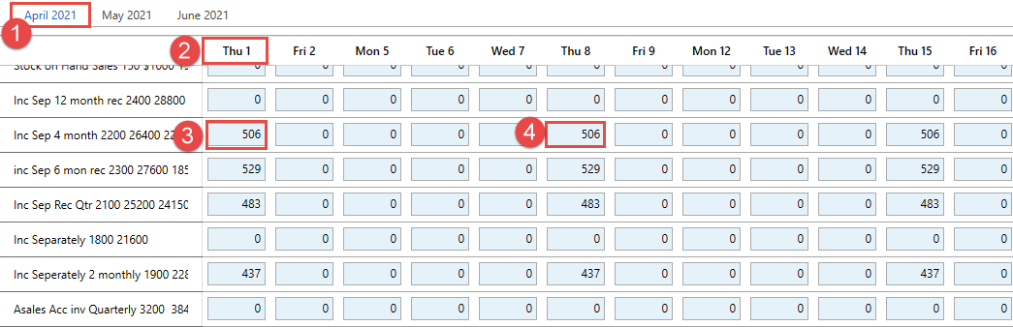

- The 3 months - select the month tab you want to view
- The day of the month. Note: There are no Saturdays or Sundays, but local public holidays will still show.
- The values - Inclusive of VAT, divided by the frequency and placed in the days index.
- The next receipts expected for this record.
You can now amend any value in the receipts or payments section of the worksheet.
Any amendments can be made, and the Bank Balance figure will be recalculated. These figures do not change any record budget or cashflow values and are recalculated if the record budget values are changed and a system records recalculation is run (eg by going to reports).

The receipt and payment totals are displayed at the bottom of their sections with the Net Cash movement and the expected Bank Balance for that day.
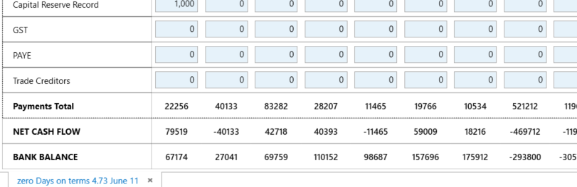

A report is available to print the expected Daily Cashflow from the report tab
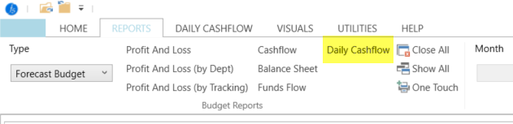
.

Rolling the Daily Cashflow month forward

When you need to move the daily cashflow forward to the next period you do this from the settings>details option and select daily cashflow period. This sets the starting period for the DCF. Once the date is changed you need to run the worksheet calculations again to recalculate the data. Just select the bank option in the worksheet and it will refresh all data.

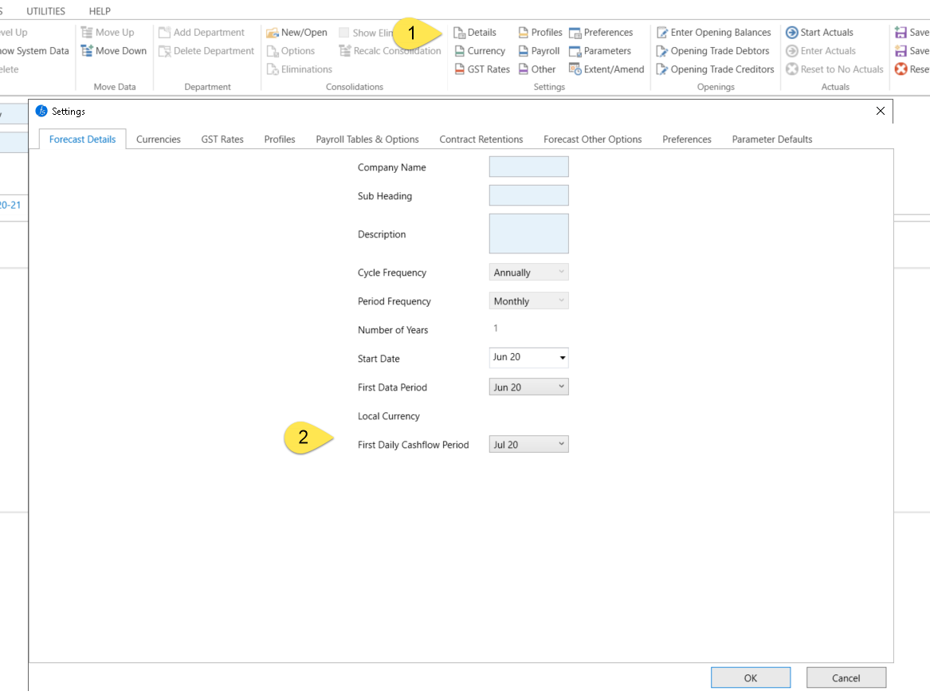

Reconciling the bank position DCF to Cashflow bank

The DCF Bank may not reconcile to the Monthly Cashflow Bank

The daily cashflow Bank Balance and the Monthly Cashflow may not agree if the month end is on a weekend and the setting of month-end bring receipts and payments forward or backwards into the previous or next month.

Any journal account transfers may create differences.

Screen Resolution and Feature visibility
Depending on your Screen Resolution, the Frequency/Index buttons on the right hand side of the Daily Cashflow screen may be difficult to access.

Similarly, the full month of the Daily Cashflow worksheet may not show on-screen.

To improve visibility - if required – please adjust your Screen Resolution which is found on
- Windows10/Settings/Display

End

