Could robust forecasting software help directors and auditors do a better job – for the benefit of shareholders?
Investors have been shocked by recent corporate scandals such as Carillion, Patisserie Valerie and Steinhoff International in South Africa ….
Directors’ duties are onerous and the obligations – at least for those premium listed companies on the LSE – are clearly set out in the UK Corporate Governance Code 2018 (CGC) and now for large unlisted UK companies, in the Wates Principles due for release in December this year.
Non-Execs are required by the CGC to provide “constructive challenge … and hold management to account” and “The board should establish formal and transparent policies and procedures to ensure the independence and effectiveness of internal and external audit functions and satisfy itself on the integrity of financial and narrative statements.” It also charges directors that when carrying out “robust assessment of the company’s emerging and principle risks”, they consider those risks that “might threaten the company’s business model, future performance, solvency or liquidity and reputation.”
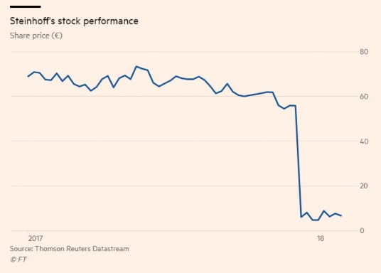
These injunctions, clearly well intentioned, weren’t enough to prevent Carillion, the second largest contractor in the UK from going bust in January with £29m in cash but liabilities of £7billion! The UK Parliamentary Report on Carillion makes sobering reading (and should be compulsory reading for finance students everywhere!). In their Conclusion the Parliamentarians, whilst admitting that most companies aren’t run with Carillion’s reckless short-termism, warn that Carillion could happen again and suggest “Government (should) grasp the initiative with an ambitious and wide-ranging set of reforms that reset our systems of corporate accountability in the long-term public interest”.
In South Africa the collapse of Steinhoff International, listed in Johannesburg and Frankfurt and the owner of Poundland in the UK, Mattress Group in the US and Conformama in France came like a “bolt out of the blue” to Christo Wiese, who lost his status as one of the richest men in Africa and Steinhoff’s Chairman when Steinhoff lost 98% - $15bn - of its share value.
Wiese learnt of Steinhoff’s troubles three days before the accounts were due to be finalised in December 2017. But not all were as surprised by the collapse. Magda Wierzycka, of Sygnia, Cape Town based fundmanager said it took her “exactly half an hour to go through Steinhoff’s accounts and conclude that its dealmaking made no sense.”
The UK market was again rocked in October by the near collapse of Patisserie Valerie where the question wasn’t so much where the cash had gone, but where it had come from? The Board discovered the company had used up almost £10m of bank credit they didn’t know they had! The company was pulled back from the brink by the injection of £20m of interest free loans by the chairman and an emergency share issue at 88% below the pre-suspension price! Apart from destruction of their investment value, investors were further angered to discover the CEO and Finance Director had been awarded millions of pounds of share bonuses without shareholder notification.
Directors blindsided, recklessness, fraud, auditors incompetence, poor or non-existent governance abound in these horror stories. What can be done to improve the situation for the (well-intentioned) directors, the wide-awake auditors and long-suffering investors? Its clear the traditional mechanisms have failed investors dreadfully in the referenced entities resulting in shareholders suffering huge losses and, In the words of the Carillion Parliamentary Report, the need to “reset our systems of corporate accountability in the long-term public interest.”
Perhaps one answer may be found in an article in the FT by Neil Chisman that backward looking accounts don’t help the shareholders who rather need “management each year to update and publish its forecast, then the financial system would be much more effective, bringing a raft of benefits.”
Chisman proposes public companies use historic cost accounting with reduced accounting standards. Companies would publish auditable ten year forecasts with results in the same format, together with their calculated cost of capital, estimated company valuations and indicated share price. He speculates that forecasting standards would evolve, allowing analysts to “put their efforts more usefully into reviewing and criticising management’s forecast, valuation and current year’s results in comparison with previous forecasts” leading to sharper focus on “credible forecast cashflows than spurious definitions of profit”, better results and “millions of private companies would be freed from the burden of producing complicated accounts that benefit no one.”
Forecast5 Limited, New Zealand and UK distributor, KBR Ltd, accept this challenge. Our software, Forecast 5, produces integrated Cashflow, Balance Sheet, Profit and Loss and FundsFlow Statements for upto 15 years together with variance analyses, comparing forecasts to actuals, including KPIs and rolling forecasts. Forecast 5 handles virtually every business scenario, such as forex, consolidations, contract retentions, services, manufacturing, stock and WIP, factoring, payroll modelling, not-for-profits and integrates with various accounting packages.
Armed with robust forecasts non-execs, shareholders and auditors should have constructively challenged management in Steinhoff, Carillion and Patisserie Valerie demanding to know – What’ve you done with the cash!

For a demonstration, please contact Johnny Kipps at UK distributor, KBR Ltd, on 07770 608 900, Johnny@Forecast5.co.uk, or download a 21-day trial at www.forecast5.co.uk/trial/

UK Corporate Governance Code 2018, Principle H
Ibid, Principle M.
Ibid, Note 28, and
Ibid, Footnote 9.
UK Parliament Enquiry into the collapse of Carillion, Published 16 May 2018
FT, October 24 & November 15 2018
FT, September 27, 2018

