Our developers at Forecast 5 could not get into the back end of Sage Winforecast, making it impossible for them to create an easy "one click" migration for your data.
However, if you follow the steps below you are able to bring your data across:
- Open a new Forecast5 forecast.
- Set parameters to the correct defaults and set up details as required
3. Create the exact same section names in Forecast 5 as you have in Winforecast.
Remember this step is case sensitive!
Check the section type is correct e.g. sales or costs etc.
4. Click Save in Forecast5
5. Go to Winforecast
6. Right click and export record list into Excel. Save the Excel file.
7. Check carefully through the Section and Record names and remove any apostrophe commas, eg, Directors' Loans should be amended to read Directors Loans.
8. Highlight the forecast in Excel and hit Cntrl-C to copy.
9. Go to Forecast 5 and select "Import Record List" on the Utilities tab.
10. Then check each section is the correct type e.g. sales or costs, currency etc.
11. Now edit each record to the correct record style cash flow etc.
12. Run P&L and Balance Sheet reports to see figures balance and match the Winforecast5 values.

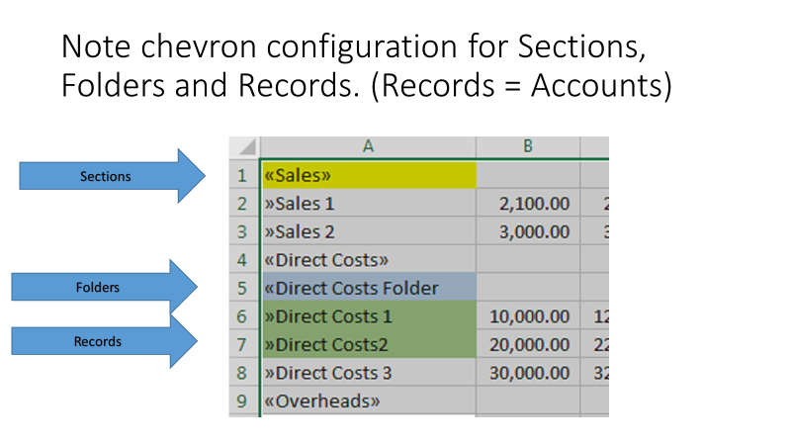
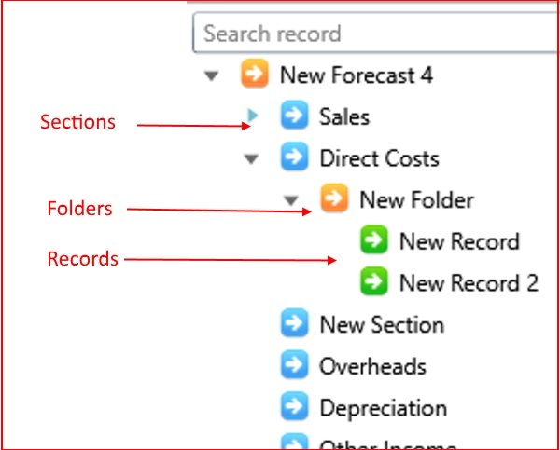

<<Sections>>
The list of records in the Forecast Explorer is divided into sections.

<<Folders
You use Folders when you need to forecast at a greater level of detail than normally displayed on the forecast reports. For example, you may have a pool of 20 motor vehicles and need to enter the details of each separately, but you only want minimal information listed on the reports. With folders you can record this down to 5 levels.

>>Records
Records are the basic tools of modelling in Forecast5.

